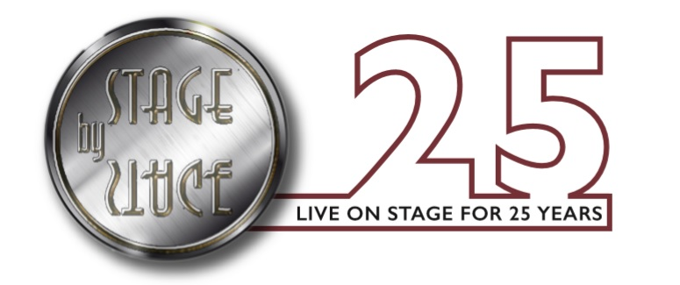

Fire Safety Policy
Revised January 2019

General
The Company is a responsible employer that takes our fire safety duties seriously. For this reason we have formulated this policy to help us comply with our legal obligations to staff and visitors under the Regulatory Reform (Fire Safety) Order 2005 (The Order).
This policy addresses our obligation under the order that requires the company to:
- Develop a policy to minimize the risks associated with fire
- Reduce the risk of an outbreak of fire
- Reduce the risk of the spread of fire
- Provide a means of escape
- Demonstrate preventive action
- Maintain documentation and records in respect of fire safety management
This fire safety policy also forms part of our General Health and Safety Policy, and is supplemented by our No Smoking / Smoke Free Policy.

The Responsible Person
The Company has appointed a ‘responsible person’ who is charged with the responsibility to ensure the safety of our employees, any person who may legally come into our premises and anyone not on the premises but who may be affected. The Responsible Person shall make sure as far as is reasonably practical that everyone on the premises, or nearby, can escape safely if there is a fire.
The persons appointed are: Ian Trafford & Tanya Trafford.
[Where responsibility is shared with other responsible persons (e.g. adjacent premises, Landlord / Tennant or multiple tenancy building) we are required to co-operate by sharing information and collaborating in provision of measures.]
The responsible person must carry out [or ensure that a competent person carries out] a Fire Safety Risk Assessment.

Competent Persons
The company will appoint competent persons to carry out the following duties:
- Fire Marshal(s) (nominated competent person)
- To carry out fire fighting duties
- Make contact with the emergency services
- Assist in evacuations.
The names and duties of all competent persons will be displayed on the safety notice board(s) within the premises.
A competent person can only be regarded as competent if they have the appropriate level of training, experience, and knowledge.

Documentation & Records
The Company documents and keeps records to prove that we have acted responsibly. The lack of records could leave the matter open to doubt. Inspectors will require inspection of our records during any enforcement visit and, therefore, the following records will be kept (together, in the same file) at all Company premises:
- The Fire Safety Policy
- No Smoking / Smoke Free Policy
- Fire evacuation procedures
- Detailed records of all fire training.
- A record of all fire drills (at least one per year) listing all attendees, evacuation times and any comments.
- Records of weekly tests of fire alarms, fire exits.
- Records of weekly flow tests of sprinkler systems (where fitted)
- Records of wet and dry tests of dry rising mains (where fitted
- Record of annual inspection and test of all fire fighting equipment
- Records of periodic tests of emergency lighting (where fitted)
- Records of all scheduled and unscheduled maintenance of fire detection and alarm systems
- [Records of inspection, risk assessment and maintenance of workplace and electrical equipment, storage of hazardous substances and other hazards identified with fire safety]

Employee’s Duties
All employees have a duty to take reasonable steps to ensure that they do not place themselves or others at risk of harm. They are also expected to co-operate fully with us in complying with any procedures that we may introduce as a measure to protect the safety and well-being of our staff and visitors.

Communication
We will ensure that any person we employ (directly or indirectly) is provided with all information related to fire safety and consult with our employees on all matters of fire safety policy and arrangements. We will keep staff informed of any changes that are made to our fire safety procedures and fire risk assessment. We will also ensure that all visitors to our premises are briefed in the evacuation procedures and not left alone unless they are aware of, and familiar with, all available escape routes.

Procedures
The Company has introduced the following procedures in order to maintain high standards of fire safety:
- Following the appointment of the Responsible Person, that person shall make, record, review and where applicable revise Fire Safety Risk Assessments. This task may be delegated by the Responsible Person to some other “competent” person.
- The Fire Safety Risk Assessments must take into consideration everyone who may come on our premises, whether they are employees, visitors or members of the public. Particular attention will be paid to people who may have a disability or anyone with special needs.
- The fire evacuation procedures will be practiced at least annually.
- All employees will be given training, including ‘the action to be taken’ when they commence employment and will receive refresher training as appropriate. Further training would be required if there were any change that may affect fire safety. All training will be provided during normal working hours.
- It is company policy that all staff will be trained in the use of fire extinguishers whether or not they have been given specific fire fighting duties.
- All escape routes will be established, kept in good working order and free from obstruction at all times. Operation of fire exit doors will be tested and recorded in the fire log on a weekly basis.
- Fire fighting equipment will be provided. In general this means fire extinguishers but additional provision of fire blankets, hoses or sprinklers may be made where deemed appropriate by the findings of the risk assessment.
- All fire related equipment will be regularly serviced and maintained by a competent person. If any employee notices defective or missing equipment, they must report it to a manager.
- An appropriate fire detection and alarm system will be provided. The type and extent of the alarm system provided will be based on the findings of the risk assessment. Alarm systems will be tested regularly. Staff will be told when a test is scheduled.
- Emergency lighting will be provided for escape routes where applicable. The need for and the extent of the system will be determined by the findings of the risk assessment.
- The risk of fire spread will be controlled by the provision of fire resisting construction, and or fire/smoke resisting doors. These provisions will be kept in good order as part of our regular maintenance schedule. All employees are required to ensure that any fire door provided remains closed at all times.
- Any other safety systems provided will be checked regularly to ensure correct operation, where necessary e.g. emergency lighting, fire doors etc.
- Appropriate signs and notices will be displayed, giving appropriate instructions to employees and others in the event of a fire. In addition signs will be provided to indicate the position of fire extinguishers, fire alarm call points and, to indicate the emergency exit routes.
- This policy forms part of our employee’s terms and conditions of employment. Failure to comply may be treated as a disciplinary matter.
The policy statement will be regularly reviewed and updated as necessary. The management team endorses this policy and is fully committed to its’ implementation.

Name: | Ian Trafford
Position: | Head of Centre
Signature:
Date: | 1st January 2019

